Parent Portal - Account Setup Instructions
Spanish Version

We are excited to have you begin the school year with information on creating an Infinite Campus Parent Portal account to access data for your child. The Portal contains update to date information on your child’s attendance, schedule, grades, assignments (grades 4-12 only), and messages from teachers.

NOTE: Please do not use your student’s account to login it may affect your student’s ability to log into other resources.

Parents living in the same household as their student can use the following steps to create an account:

- You will need the Student ID and Birthdate for one of your children. The Student ID can be found on the student’s schedule.
- If you do not have an Activation Key, go to https://campus.fcboe.org/campus/K12_Custom/cParent/index.jsp?appName=fayette to retrieve a list of keys for parents living in the same household as the student. For parents who do not live in the same household, contact your child’s school for this information.
- Enter the Student ID and Birthdate for one of the students in the household to Print the Activation Keys for all Parent contacts in the household. Each parent can create a separate portal account if desired.
- Once you retrieve your Activation Key, return to the Portal site and click the If you have been assigned a Campus Portal Activation Key, click here link and enter the Activation Key in the text boxes provided.
- Click Submit to continue to the next step.
- Enter your desired Username and Password information and click the Create Account button.
NOTE: Please do NOT use a numeric only username as it may conflict with a student account.
- Return to the Login page and enter the Username and Password you setup in the previous step.

For more expanded directions with screenshots, click here.

Infinite Campus also provides the ability for you to customize how you receive automated emails and phone calls generated by your school. After logging into your new account, you can update your Contact Preferences in the User Account area. In the example below, the parent has selected General phone calls to dial the Home Phone. High Priority, Attendance and Behavior phone calls are set to dial the Cell Phone. Additionally, the email address is set to receive all message types, including Teacher Emails.

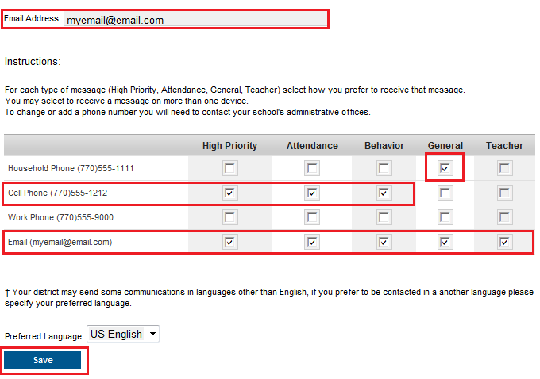

The email address is editable on this screen. If phone numbers need to be modified, please let your child’s school know. Remember, this is the contact information for the person associated with this account. Please do not login using your child’s account as it may affect their ability to receive notifications.

Additional Resources from Infinite Campus:
Student / Parent Portal Overview (updated 7/1/2018)
Parent Features and Family Updates on Portal (updated 8/1/2014)
Portal Account Management and Contact Preferences (added 8/1/2014)

